Benefits of Looping:

* Less tedious
* Can accommodate different users.

Program instructions can be repeated dynamically.

Four Steps:

Initialize: Set a starting variable.

Test: If True, loop

Loop Body: What gets looped

Update: Should loop continue?

A single loop is an Iteration.

1. Identify statements that need to be repeated

2. Wrap in loop

3. Code the loop conditon continuation

Two Types:

Counter-Controlled Loop: for I in range (5)

Sentinel Controlled Loop: WHILE time < closing time:

* Value that signifies end of loop

**Python**

1. Identify the loop to be repeated

2. While True:

3. Code loop continuation condition

while count <= N:

Add user friendly message with print.

Ask the user to Enter a Reasonable value with Loop:

To loop through a word

for iterated_variable in ‘hello world’

print(iterated_variable)

for I in [1,2,3,4,5,6]

for I in range(6)

range(start, end, step)

sum of [1,2,3,4] is not the same as

sum of [5,4,3,2]

Therefore:

sum of range(1,5,1) is not the same as

sum of range(5,1,-1)

**For-else-break-continue**

For: Repeat Loop for each Iteration

Else: Branching Option

*Break: Exit loop now, skip Else (even if in same indent)

Continue: Go to top of loop now

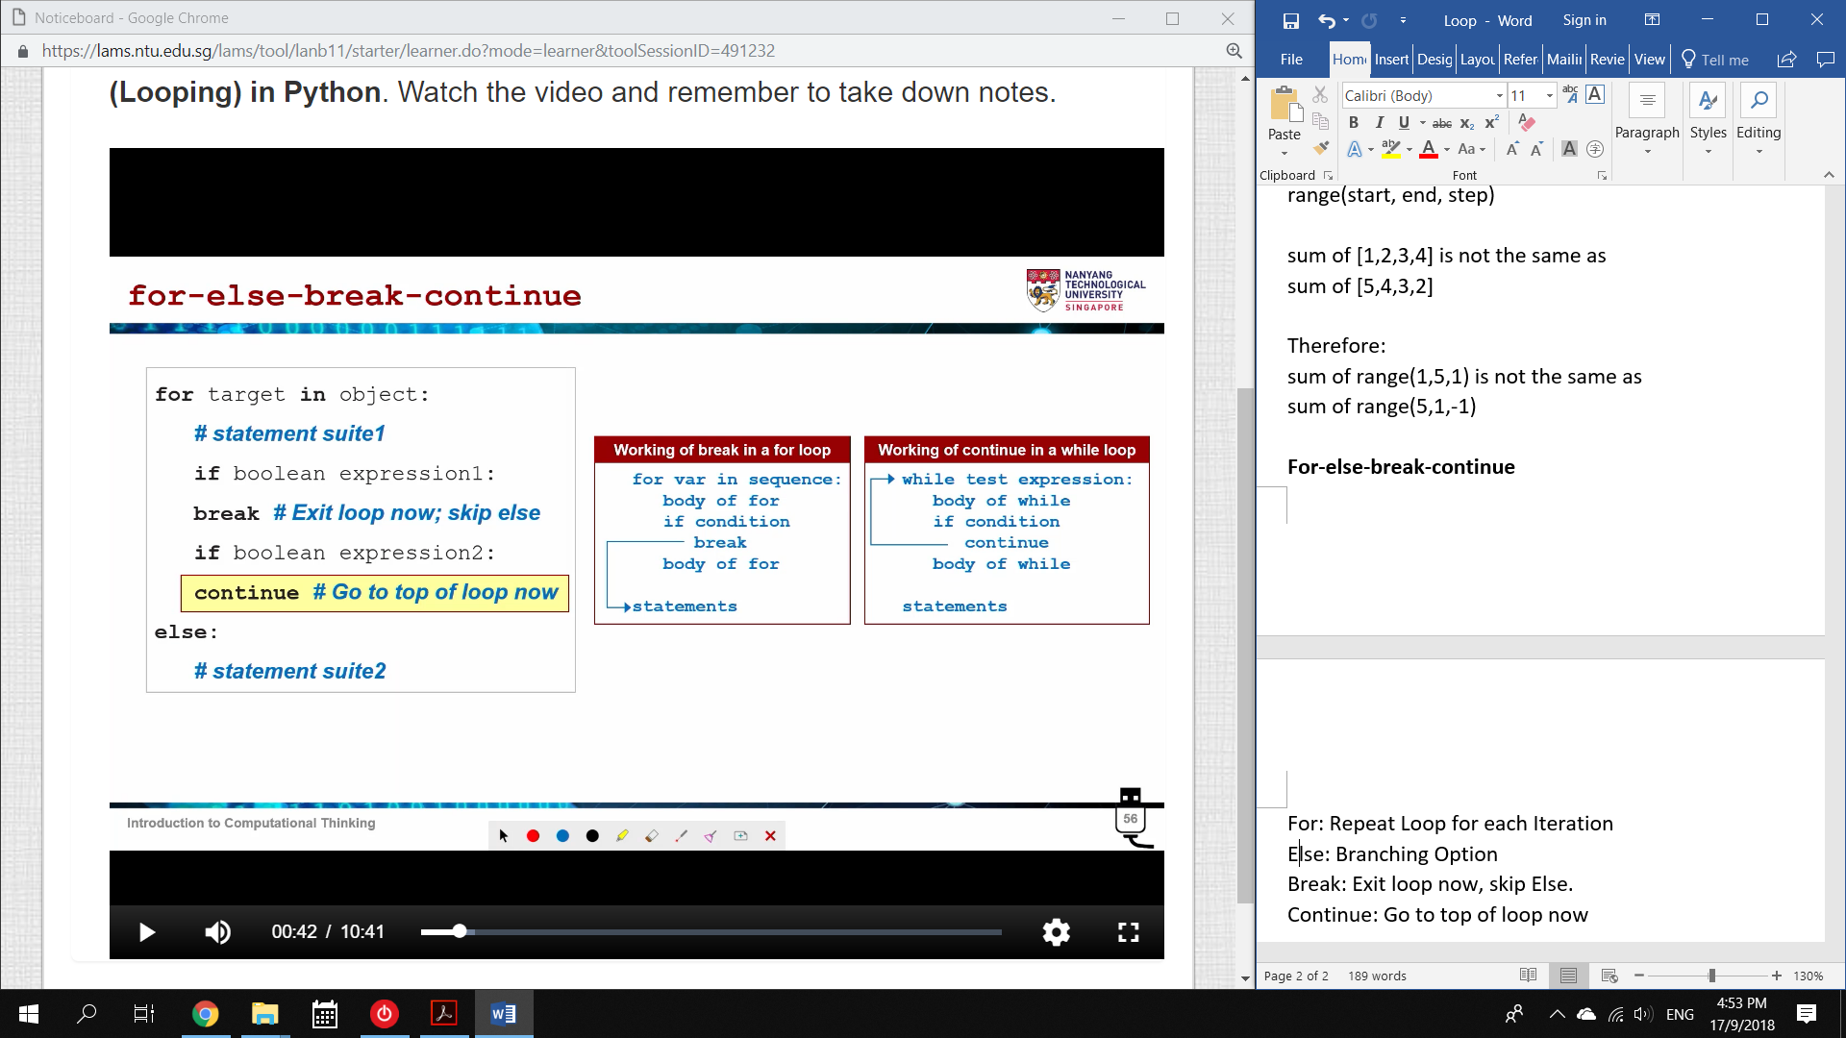

Prime or Not Prime

1. Divide k by all numbers 2 < n < k/2

2. If the remainder is 0, then n is a factor of k

k = int(input(“Please enter an integer: “))

for n in range(2, int(k/2)):

if k%n == 0:

isprime == “no”

break

else:

isprime = “yes” *loop is not Exited*

*Note: If the loop goes through and does not break:*

* *isprime has no value*
* *Exits the loop and goes to else*
* *isprime becomes “yes”*

Nested loops are

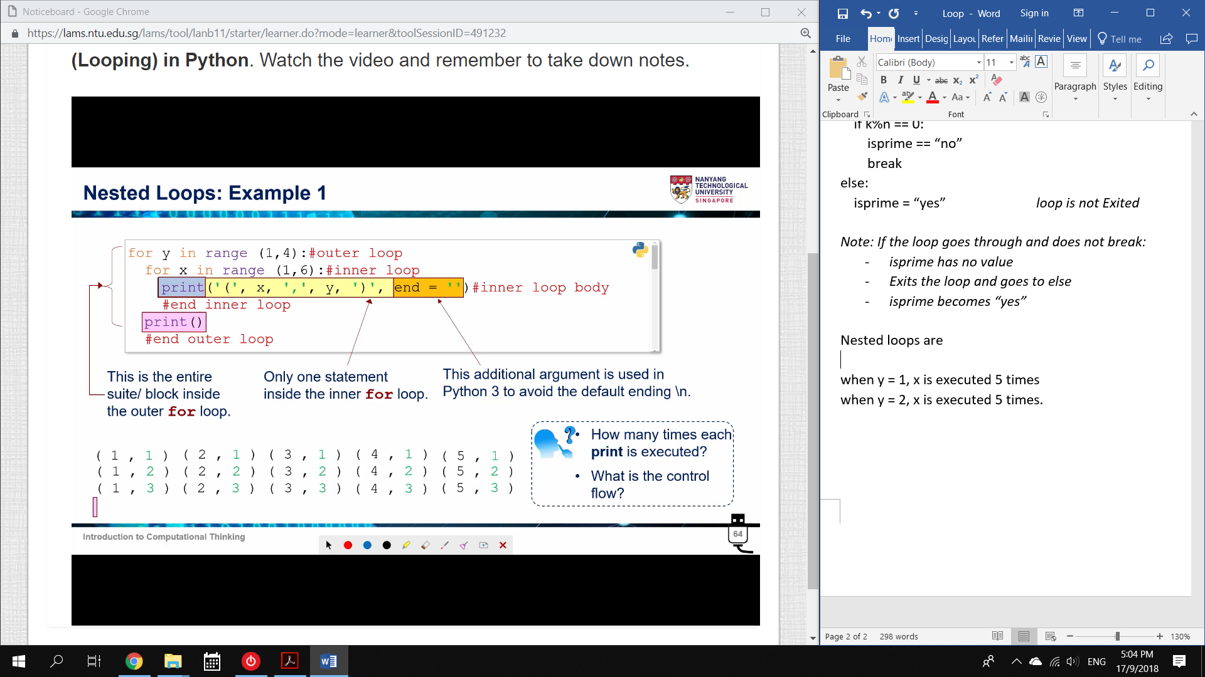when y = 1, x is executed 5 times

when y = 2, x is executed 5 times.

when y = 3, x is executed 5 times.

Multiplication Table

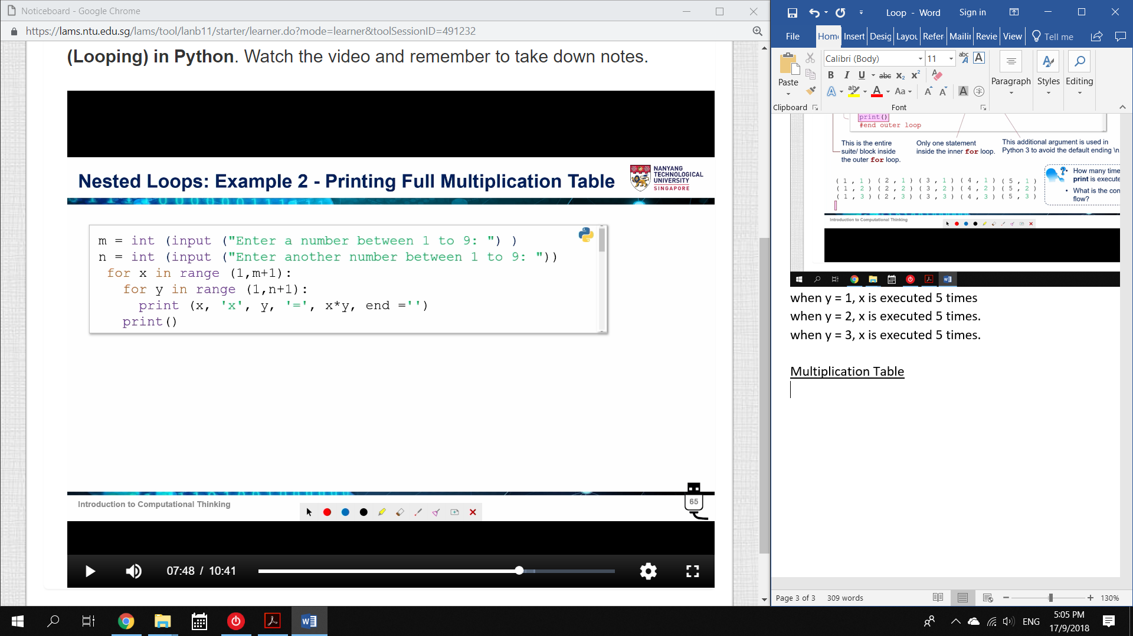

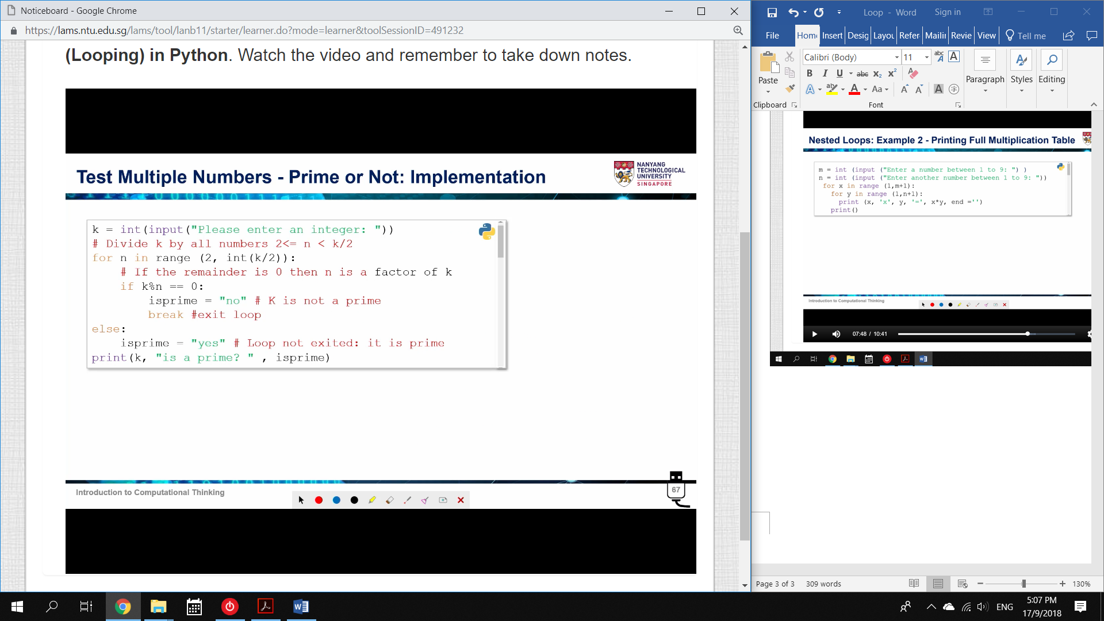

while loop allows multiple iterations of user input.

Note: break only affects the most recent loop.

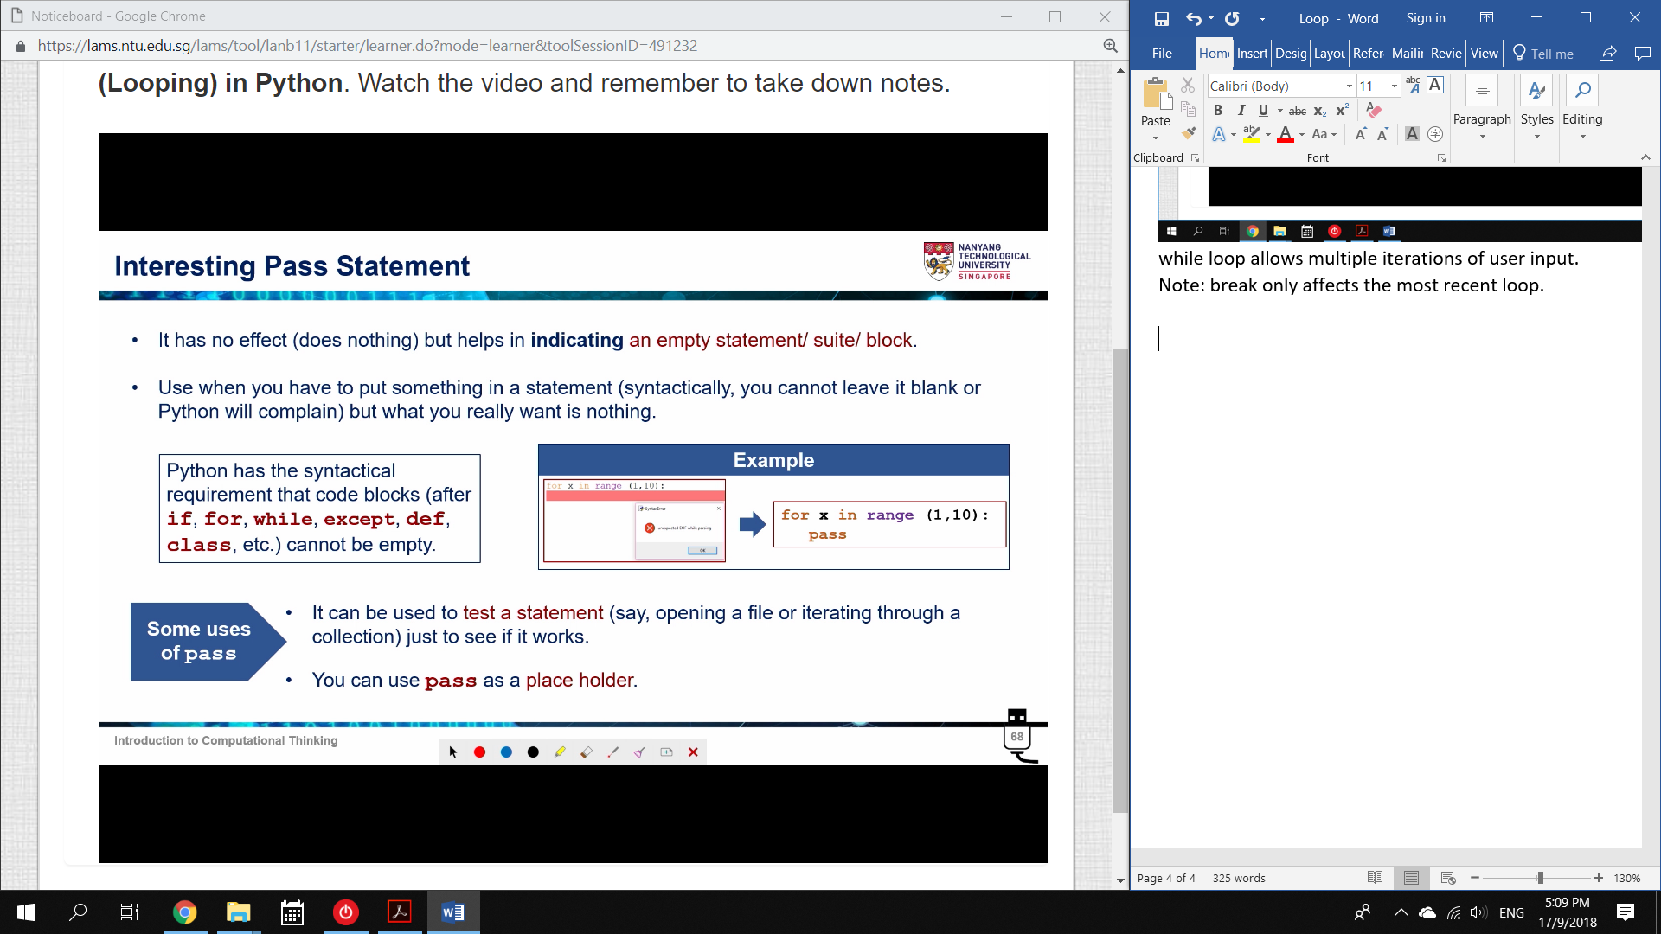

pass can be used to test if your code works (before you add more code)